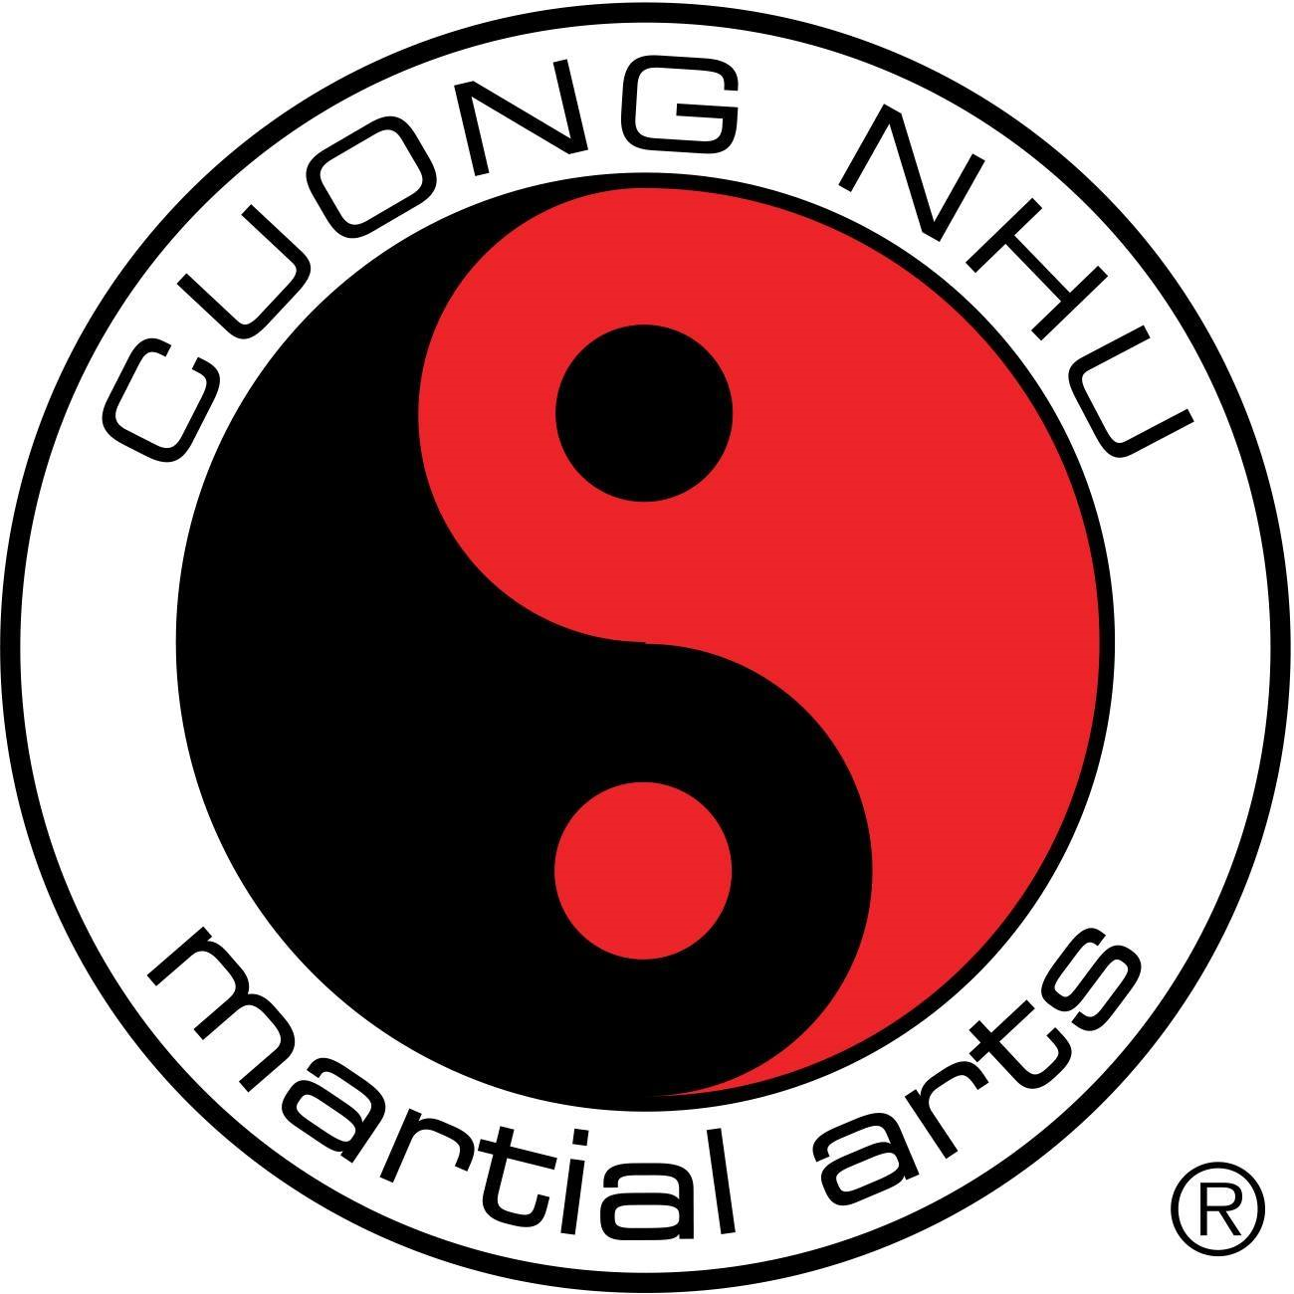

**Karate**

**We strive to educate children not only in martial arts, but in all aspects of life. We teach discipline, respect and coordination in a fun filled environment. Our after school program has been serving the local community since 2005. We believe the martial arts are good for you physically, mentally and spiritually. Our goal is to build better martial artists, as well as better people.**

**To Sign your child up go to** [**Howard Middle (atlantakarate.org)**](http://www.atlantakarate.org/howard-middle.html) **You can get more information about our program at our website at atlantkarate.org**

**You can also contact me via email at** [**atlantakarate@gmail.com**](mailto:atlantakarate@gmail.com) **or call me at 404 697 8222.**

**We look forward to working with your child in the near future.**